Ballistic Projectile

Student’s Name
Submission Date

Objectives
This lab is aimed at achieving the following objectives: to understand and apply the principles underlying projectile motion so as to make a verifiable retro diction, to probe the connection between Galileo's Principle of Relativity and the principles underlying projectile motion, to use the laws of physics in a vivid forensic investigation, and to use analysis and computations to determine where you must place your ballistic pendulum so that it successfully fires a brass sphere into a cup.

Equipment used
The following are the equipment used during this lab experiment: a Simulated Standard Ballistic Pendulum Apparatus & Ball, a Simulated Standard Photogate & Digital Timer, and a Simulated Medium-Size Paper and a Wax-Coated Cup.

Part 1 answers
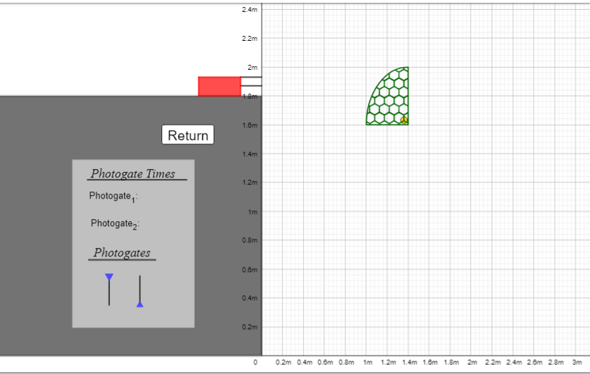
In 1 - 3 complete sentences of English, explain what you measured for a displacement and why this measurement is relevant for a calculation of the sphere's velocity through the photogate.
The displacement was measured in m units from the start point to the end corner of the net, and it was ranging with a minimum of 0.1385 m and a maximum of 0.1395. Without uncertainties, the horizontal displacement was taken to be 0.139 m. To obtain the velocity, the displacement was divided by the average time that the ball took to enter the center of the photogate. This measurement is relevant considering the dimensions of a sphere that they are small to use other units of measurements with other instruments.
Let x stand for Horizontal Displacement. In meters, enter your displacement: x = _________0.139_______ m.
Record the times and determine the horizontal velocity.
The sphere takes 0.2068 to reach at the photogate. The velocity is thus:
V= 0.139m / 0.2068 s = 0.672 m/s
Using markings on the simulation, measure the height from which your sphere will be fired from the ballistic pendulum: in other words, measure the vertical displacement that the bullet will have in the course of its trip. Use the variable y for vertical displacement. y = ____1.9 – 1.6 = 0.3 m______
The vertical velocity is thus:
V = 0.3m/ 0.2068 s = 1.45 m/s
At what (horizontal) range from the target was the weapon?
The horizontal range was from 0.1385 m to 0.1395 m.

Part II answers
Your final task is to determine your horizontal ranges’ . . . range! That is, what is the range of values?
The final horizontal ranges were obtained to be 0.669 m/s to 0.674 m/s

Appendices

Appendix A

The simulation
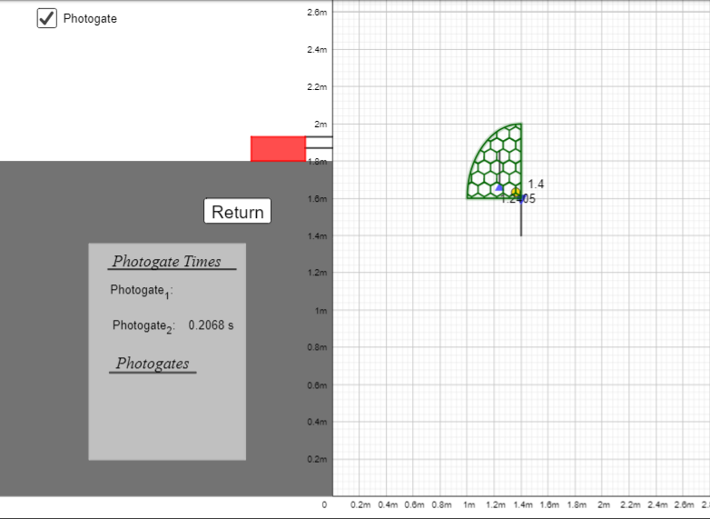

Appendix B

Calculations
